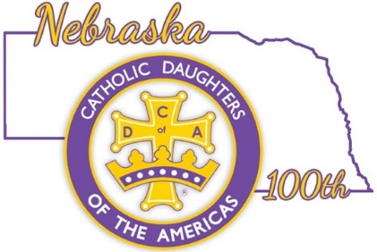

Nebraska Past State Regents
2023 -2025
Ruth Krumbach
#764 St. Mary’s
2009 – 2013

Monica Veik
#988Little Flower
2005 – 2009

Judy Reed
#2036 Our Lady of Perpetual Adoration
2002 – 2005

Kim Spicka
#2253 Queen of the Angels
1998 – 2002

Shirley Chramosta
#2007 St. James
1988 – 1992

Elaine Heng
#1122 Emmanuel
1986 - 1988

